Experiment -4A

NAME: JAI GANESH S REG NO:240701199

Detailed Documentation of 10 Wireframe Pages designed in Figma and the flowchart created in Lucidchart.

Introduction to the Children’s Treasure Application

The Children’s Treasure App is a task management application designed to help parents encourage children to complete their daily responsibilities. In this app, parents can assign tasks such as homework, cleaning the room, or reading books and attach reward points to each task. Children can view these tasks in their dashboard and mark them as completed. When tasks are completed, children earn points that are added to their total balance. These points can later be redeemed for rewards from a wish list created by the parents. The application creates a gamified environment that makes chores more engaging and motivating for children. Overall, the system helps improve responsibility, motivation, and communication between parents and children.

Flow chart

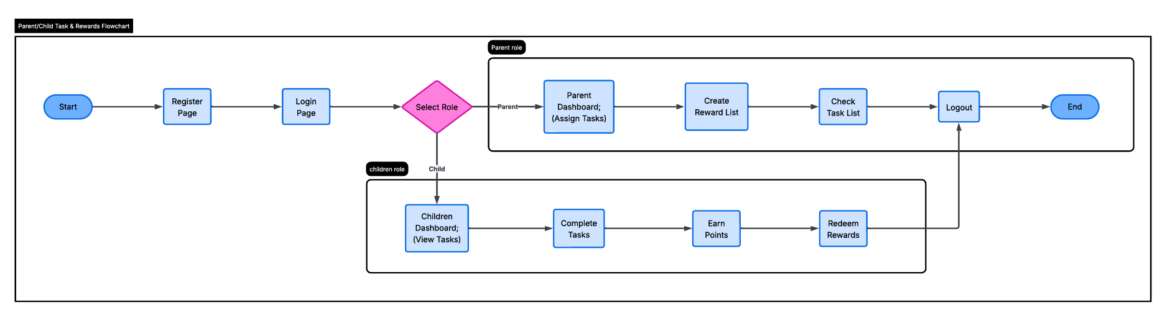

Page 1 – Register Page
- Image: Insert Register wireframe screenshot
- Elements: Name field, Password field, Password Reset option, Parent’s/Children’s toggle
- Purpose: This page allows new users to create an account. Parents and children can register separately so the system can provide role‑based access.
- User Flow: After successful registration, the user is redirected to the Login page for secure access.

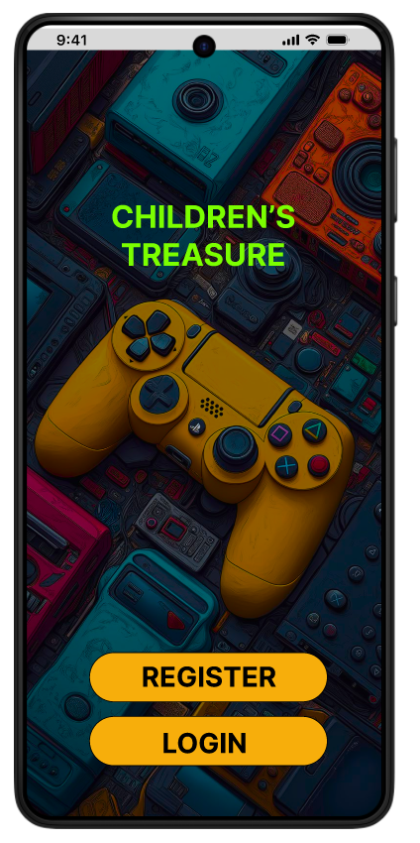

Page 2 – Login Page
- Image: Insert Login wireframe screenshot
- Elements: Name field, Password field, Reset option, Parent’s/Children’s toggle
- Purpose: This page provides secure login access for both parents and children.
- User Flow: After login, the system directs the user either to the Parents Dashboard or the Children Dashboard depending on the selected role.

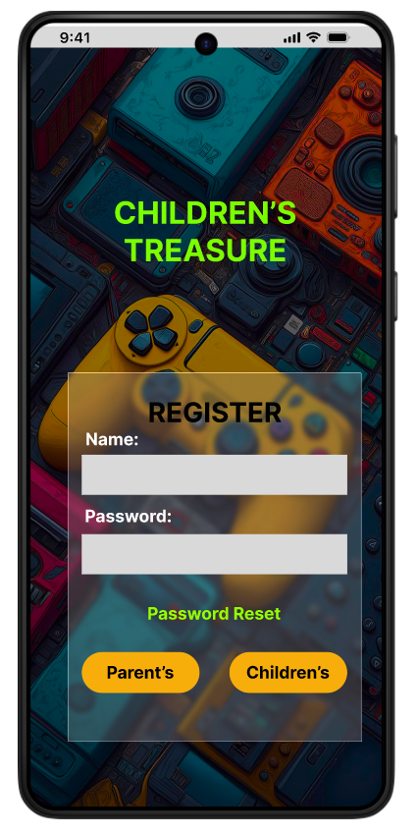

Page 3 – Parents Dashboard (Assign Work)
- Image: Insert Assign Work wireframe screenshot
- Elements: Task list such as Homework, Dog walk, Clean room, Wash clothes, Read book with reward points (+10, +17, +15, +20, +15), Submit button
- Purpose: Parents can assign tasks to children along with reward points. This makes chores more engaging and motivating.
- User Flow: After submission, the tasks appear in the Children’s Dashboard under the Works section.

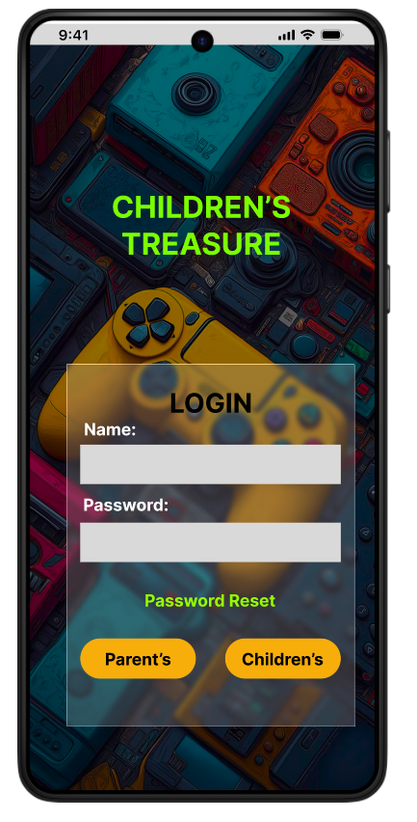

Page 4 – Parents Dashboard (Check List)
- Image: Insert Check List wireframe screenshot
- Elements: Task list without points, Submit button
- Purpose: Parents can review and track the tasks that were assigned to children.
- User Flow: This page syncs with the Children’s Dashboard and shows whether tasks are completed or still pending.

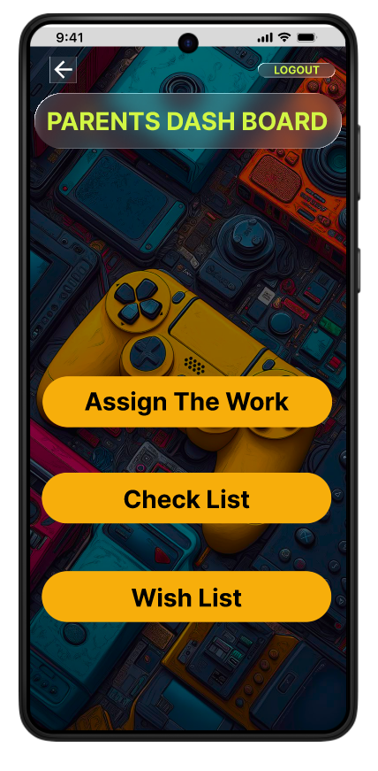

Page 5 – Parents Dashboard (Wish List)
- Image: Insert Wish List wireframe screenshot
- Elements: Cupcakes (+10), Video games (+100), Toys (+15), Digital watch (+20), Harry Potter book (+15), Submit button
- Purpose: Parents can define reward items that children can redeem using their earned points.
- User Flow: These rewards will be visible in the Children’s Wish List page.

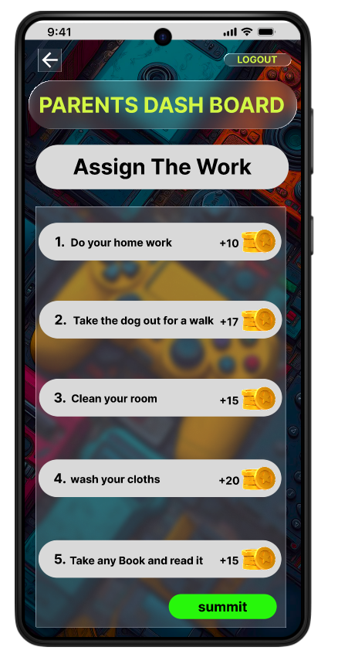

Page 6 – Children Dashboard (Overview)
- Image: Insert Children Dashboard wireframe screenshot
- Elements: Works tab, Wish List tab, Points total (+95), Logout option
- Purpose: This dashboard gives children a quick overview of their tasks and rewards.
- User Flow: Children can move to the Works page to complete tasks or to the Wish List page to redeem rewards.

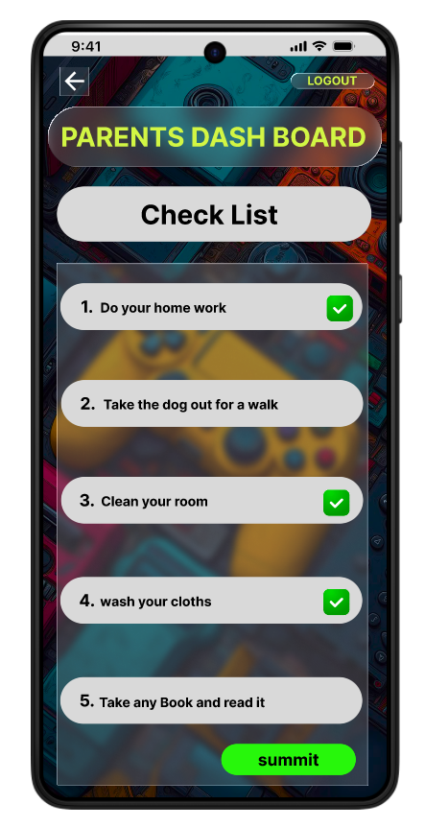

Page 7 – Children Dashboard (Works)
- Image: Insert Works wireframe screenshot
- Elements: Task list with checkboxes, Points total (+95), Submit Review button
- Purpose: Children can mark the tasks they have completed.
- User Flow: After submission, the system updates the total reward points in the dashboard.

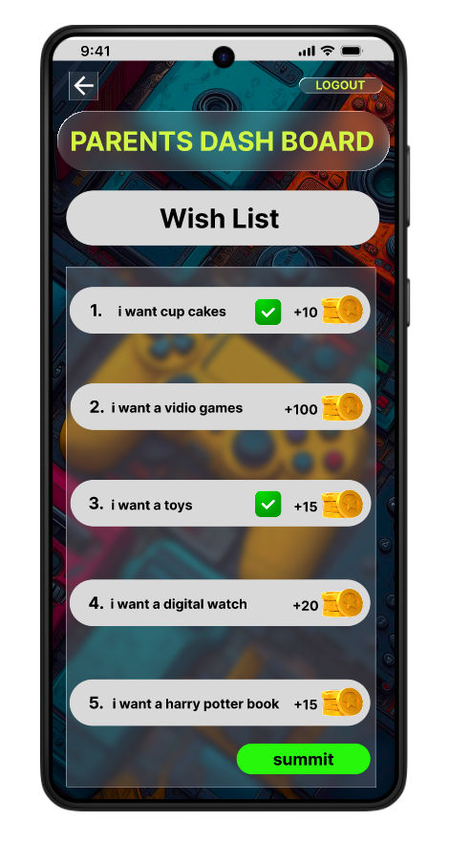

Page 8 – Children Dashboard (Wish List)
- Image: Insert Wish List wireframe screenshot
- Elements: Cupcakes ☒ (+10), Toys ☒ (+15), Video games (+100), Digital watch (+20), Harry Potter book (+15), Points total (+70), Submit Review button
- Purpose: Children can redeem rewards using their points.
- User Flow: When a reward is selected, the required points are deducted and the item is marked as redeemed.

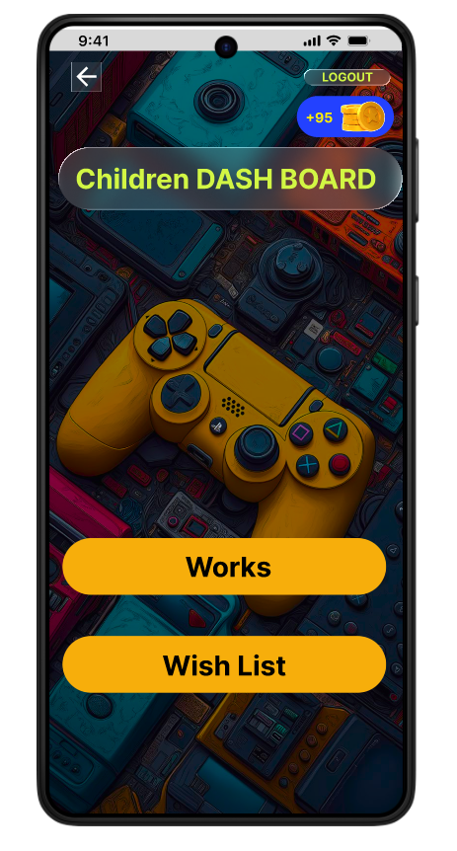

Page 9 – Logout Page
- Image: Insert Logout wireframe screenshot
- Elements: Logout button, Time (9:41), Currency symbol (€)
- Purpose: This page allows the user to securely end the session.
- User Flow: After logging out, the user is redirected back to the Login page.

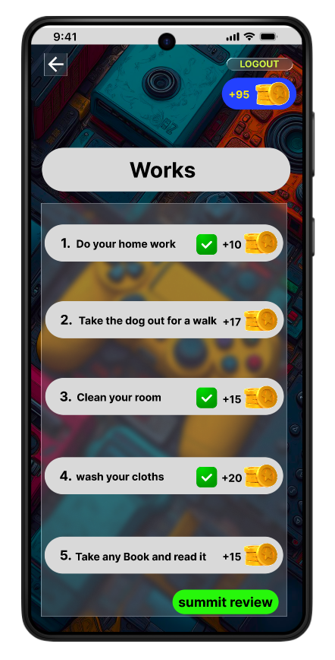

Page 10 – Summary Flow Page
- Image: Insert flow diagram or final wireframe
- Elements: Register → Login → Dashboard → Tasks → Rewards → Logout
- Purpose: This page shows the complete user journey of the application.
- User Flow: It connects all screens and demonstrates how parents assign tasks, children complete them, and rewards are redeemed.

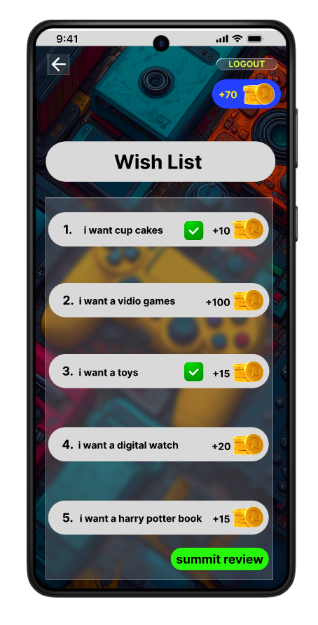

Final Section
- Summary of Flow:
- The application creates a gamified environment where parents assign tasks, children complete them, and rewards can be redeemed.
- Conclusion:
- The wireframes present a simple and user‑friendly design that balances parental control with children’s motivation.

